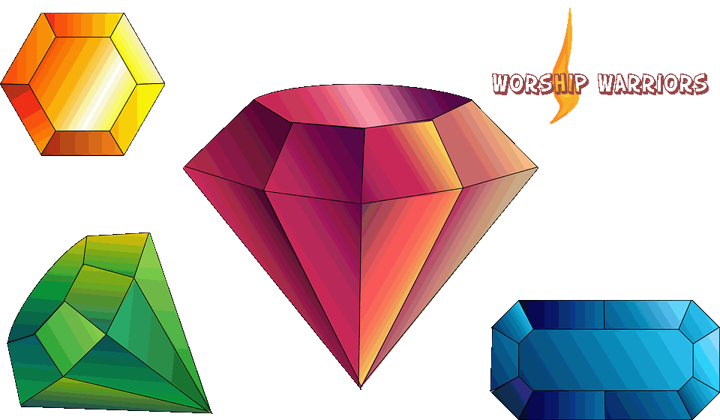

GEMSTONES OF THE BIBLE
And their Biblical Significance

GEMSTONE | Scripture | Symbol | Description
AMBER | Ez.1:4,27; 8:2 | the presence and glory of God in judgment, purification and sanctification | Hard, translucent, brownish-yellow, sometimes a glowing bronze, fossil resin of pine trees. The sweet fragrance of true Amber is quite distinct. Mainly found along the Baltic coasts of Poland, the Soviet Union, and Greece [in ancient ruins of Mycenae City].
AMETHYST | Ex. 28:19, 39:1; Rev.21:20 | the royal priesthood, kingship and majestic | Rich purple to blue-violet color of transparent quartz. The finest of these gems come from Brazil and Uruguay. It is the 9th stone decorating the high priests breastplate.
DIAMOND | Jer. 17:1; Ex. 28:18, 39:11; Eze. 28:13, 3:9; Zec. 7:12 | stability, brilliancy, virtuous and right standing with God | Colorless; it is the hardest naturally occurring substance. The impurities add color, red being very rare. Africa is by far the largest producer; diamond is mostly mined in South Africa.
EMERALD | Ex. 28:18, 39:11; Eze. 27:16, 28:13; Rev. 4:3, 21:19 | glories of God and His saints, fresh, flourishing, eternal life, growth, integrity, new life, resurrection, increase & prosperity | A variety of Beryl. Rich lush medium green heavily included to flawless. The finest qualities are mined in the famous Emerald Belt of Colombia. It is on the Breastplate of the high priest. [Ex. 28:20]
JASPER | Ex. 28:15&20, 39:13; Eze. 28:13; Rev. 4:3, 21:11,16&18 | glory of God, splendor, brightness, magnificence and beauty | Opaque variety of quartz. Color ranges from green to reddish brown to yellow having a waxy luster. Whether ancient or modern, this is a stone used for signet rings which can be engraved.
PEARL | Job 28:18; Matt. 7:6, 13:45&46; I Tim. 2:9; Rev. 17:4, 18:12, 21:21 | God's truth, God's people formed through suffering, to endure, and a costly experience. Greek term for pearl "Margaret" meaning lovely gem. | If an irritant such as a grain of sand becomes trapped within its shell, the oyster gradually covers it with layers of nacre, which form the precious pearl inside.
RUBY | Job 28:18; Prov. 3:15, 8:11, 20:15; Lam. 4:7 | preciousness, of great value, costly glories, wisdom, and prized treasure | Fiery, deep-red, transparent form of corundum. Rubies of the finest color come for the Mogok region in Burma, the violet-red (sometimes quite dark) comes principally from Thailand.
SAPPHIRE | Ex. 24:10, 28:13&18, 39:11; Job 28:6&16; Lam. 4:7; Isa. 54:11; Eze. 1:26, 10:1, 28:13; Rev. 9:17, 21:19&20 | Beauty, hardness, natural excellence, the flower Hyacinth | Tthere are many hues of this form of corundum; the most recognized is the "Star of India".
TOPAZ | Ex. 28:13&17, 39:10; Job 28:12&19; Eze. 28:13; Rev. 21:20 | beauty, worthiness, precious gem and seasonable | A colorless, blue, yellowish brown, or pink, aluminum silicate (mineral). The yellow graduating to pink are the most valued. Mined primarily in Brazil. Fine topaz is not widely used in jewelry due to the cost and rarity of it.
(compiled by Lora Rozkowski)
Compliments of:
WORSHIP WARRIORS
http://worshipwarriors.net

